**Assignment 4 : Create Stored procedure in Northwind database to insert or update arecord in a table**

---------------------------------------------------------------------------------

**1. Create a stored procedure in the Northwind database that will calculate the average value of Freight for a specified customer.Then, a business rule will be added that will be triggered before every Update and Insert command in the Orders controller,and will use the stored procedure to verify that the Freight does not exceed the average freight. If it does, a message will be displayed and the command will be cancelled.**

create procedure Avgfreight

@custId nchar(5)

as

begin

select CustomerID,avg(freight) from Orders

where CustomerID=@custId

group by CustomerID

end

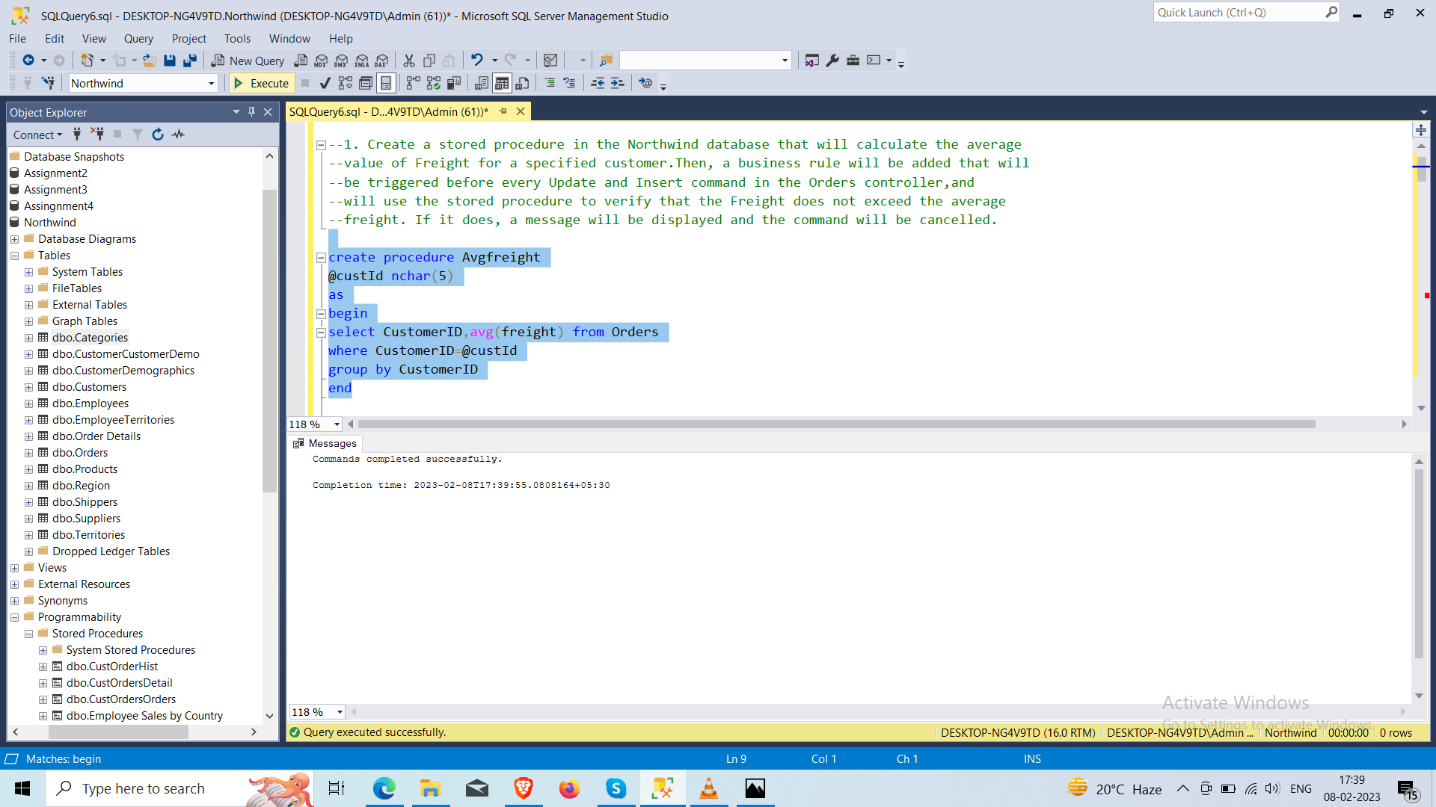

Avgfreight 'TOMsp'

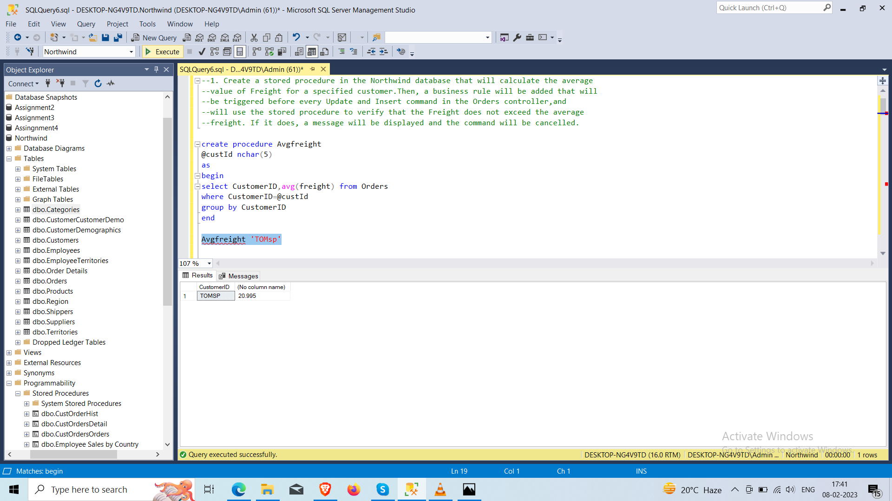**2. write a SQL query to Create Stored procedure in the Northwind database to retrieve Employee Sales by Country**

SELECT Employees.FirstName,Employees.LastName,Orders.ShipCountry,sum(Quantity) as [Total Sales]

FROM Employees

join Orders

on Employees.EmployeeID =Orders.EmployeeID

join [Order Details] on Orders.OrderID=[Order Details].OrderID

group by Employees.FirstName,Employees.LastName,ShipCountry

order by Employees.FirstName

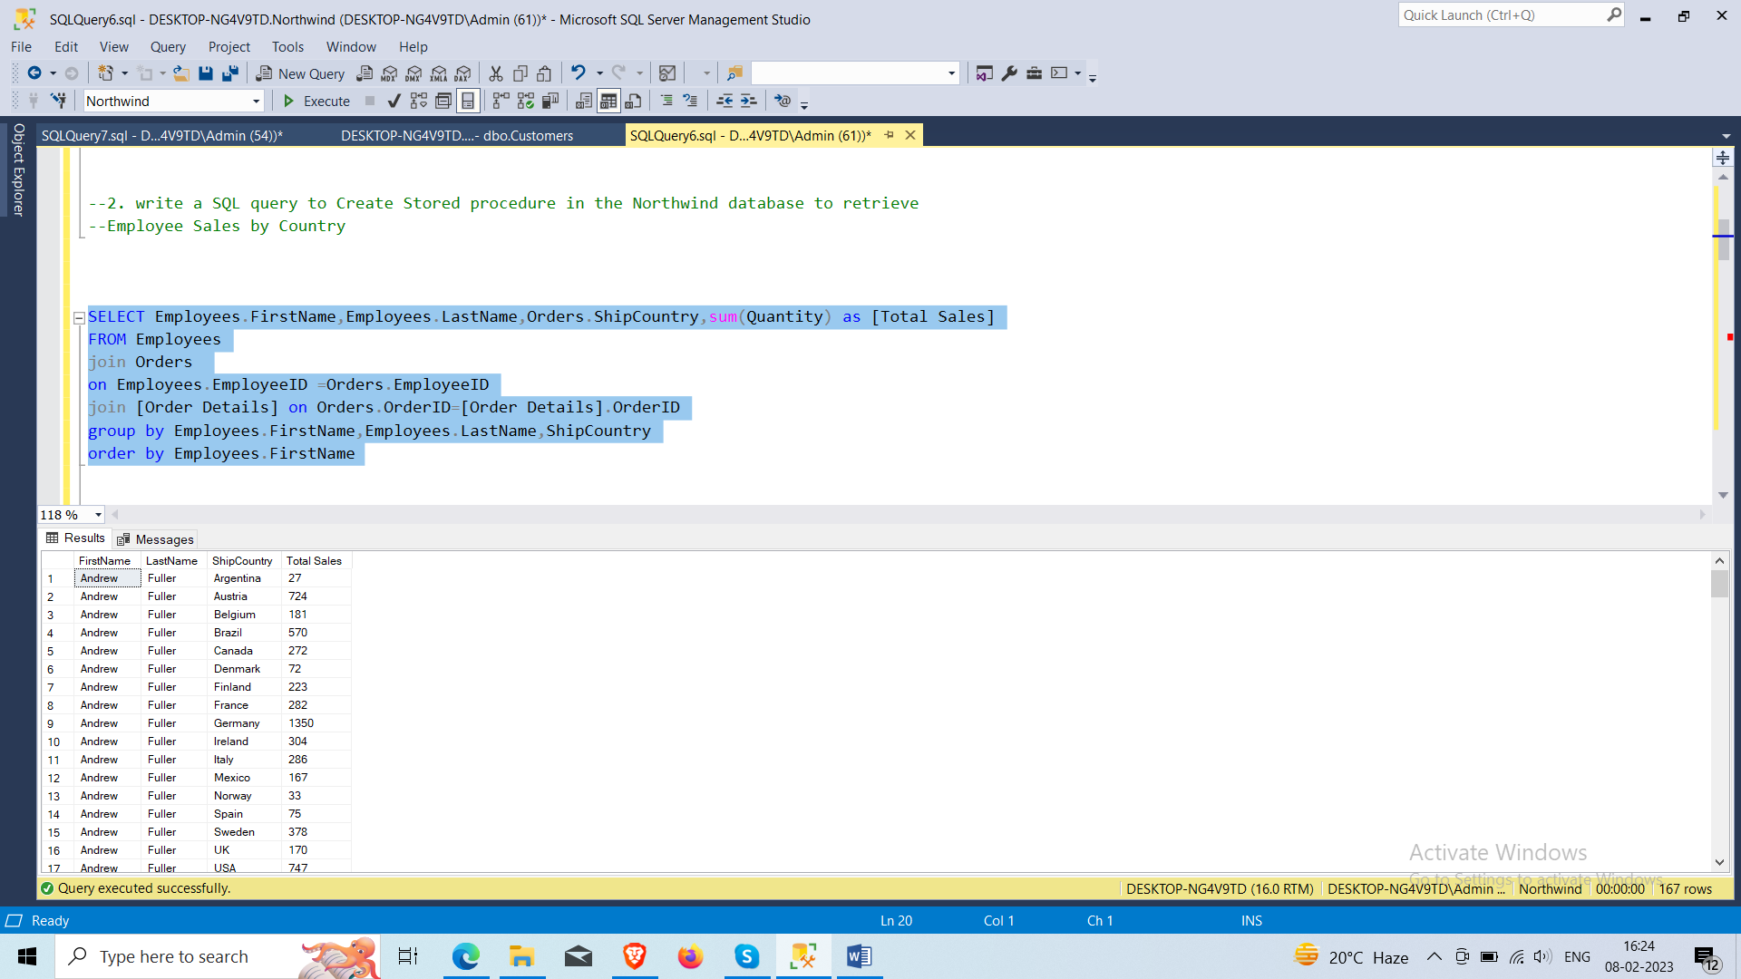

**3. write a SQL query to Create Stored procedure in the Northwind database to retrieve Sales by Year**

select year(OrderDate), count(OrderID) from Orders group by year(OrderDate)

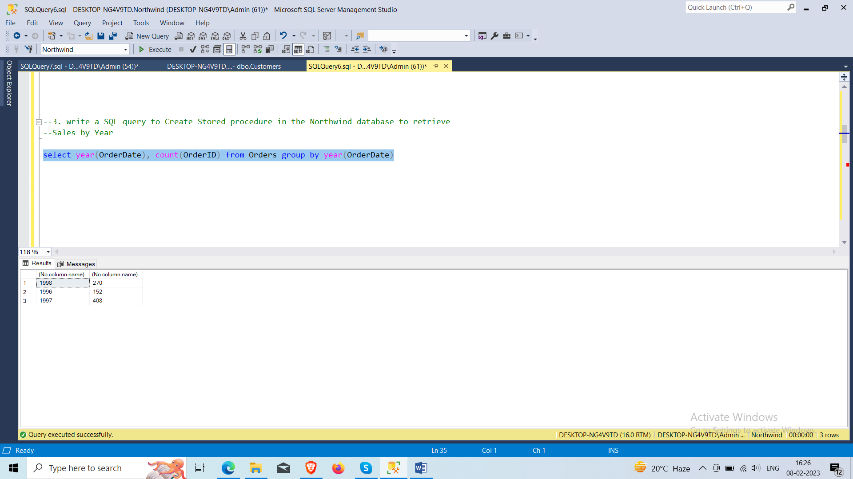

**4. write a SQL query to Create Stored procedure in the Northwind database to retrieve Sales By Category.**

select Categories.CategoryID,Categories.CategoryName,Products.ProductName,sum([Order Details].Quantity) as [total sales]

from Categories

join Products

on Categories.CategoryID=Products.CategoryID

join [Order Details]

on Products.ProductID=[Order Details].ProductID

group by ProductName,Categories.CategoryID,Categories.CategoryName

order by CategoryID,ProductName

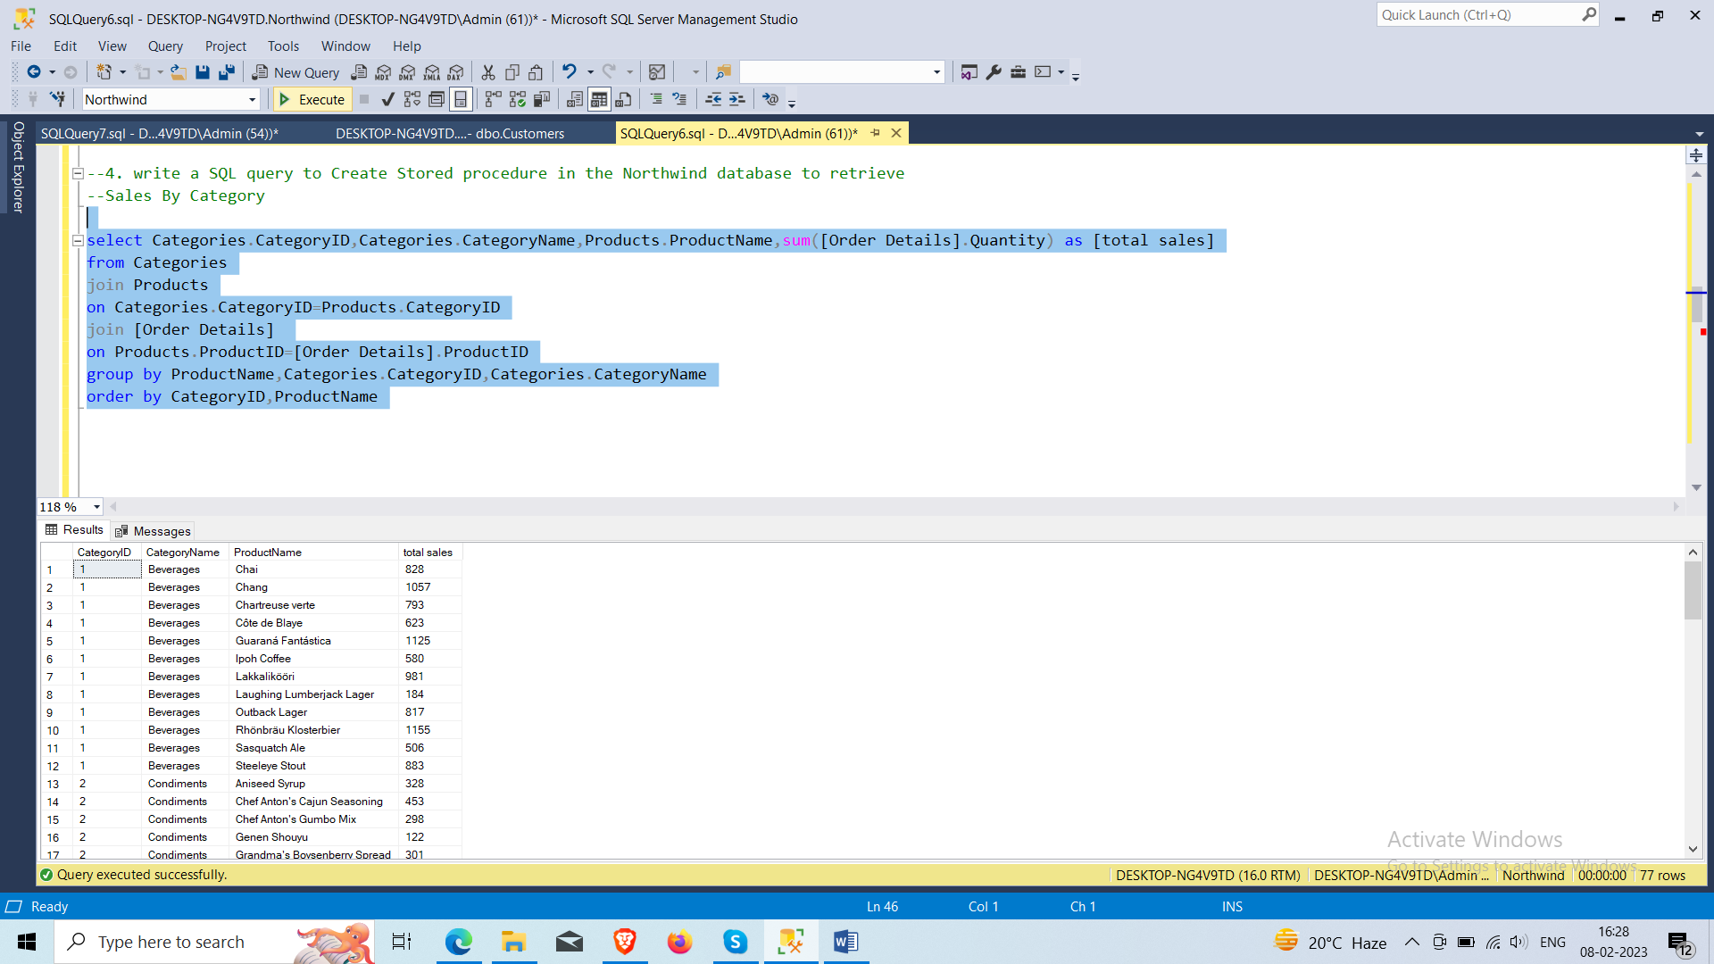

**5. write a SQL query to Create Stored procedure in the Northwind database to retrieve Ten Most Expensive Products**

select top 10* from Products

order by UnitPrice desc

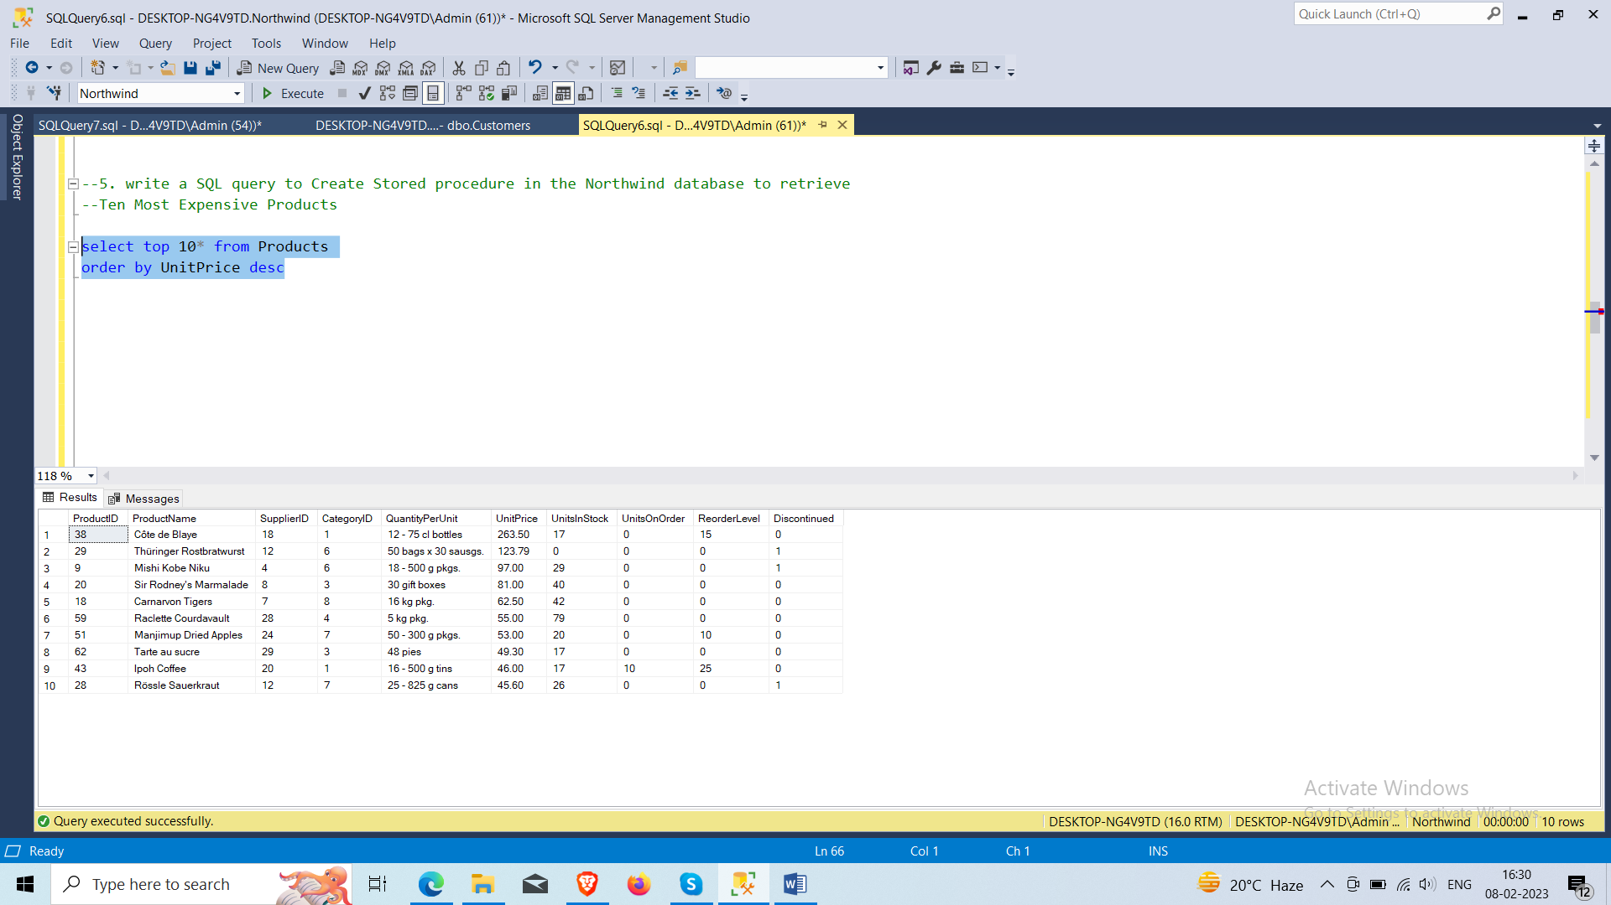

**6. write a SQL query to Create Stored procedure in the Northwind database to insert Customer Order Details**

create procedure insertcustomers

(

@cutomerID nchar(5),

@CompanyName nvarchar(40),

@ContactName nvarchar(30),

@ContactTitle nvarchar(40),

@Address nvarchar(40),

@City nvarchar(40),

@Region nvarchar(40),

@PostalCode nvarchar(40),

@Country nvarchar(40),

@Phone nvarchar(40),

@Fax nvarchar(40)

)as

begin

insert into Customers

values (@cutomerID, @CompanyName , @ContactName ,@ContactTitle, @Address , @City ,@Region ,@PostalCode ,@Country ,@Phone ,@Fax )

print 'new customer data inserted'

end

exec insertcustomers 'ABCD','Hiren','Bodar','Owner','ABCD','Bhavnagar',null,null,'gujrat',null,null

exec insertcustomers 'AB','Hi','Bo','Owner','ABCD','Bhavnagar',null,null,'gujrat',null,null

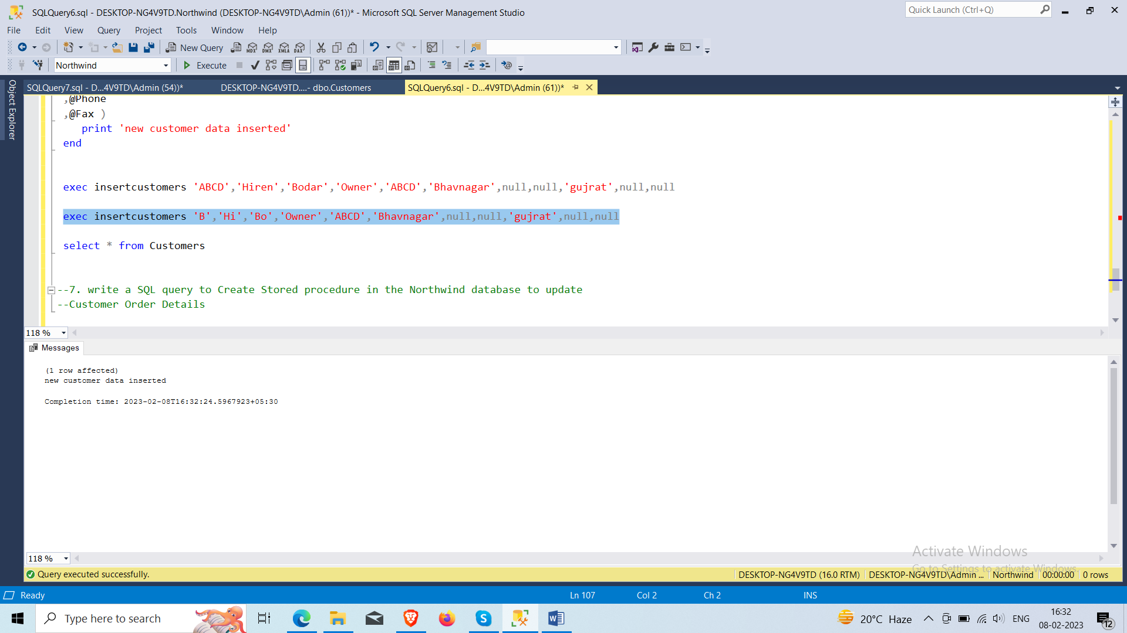

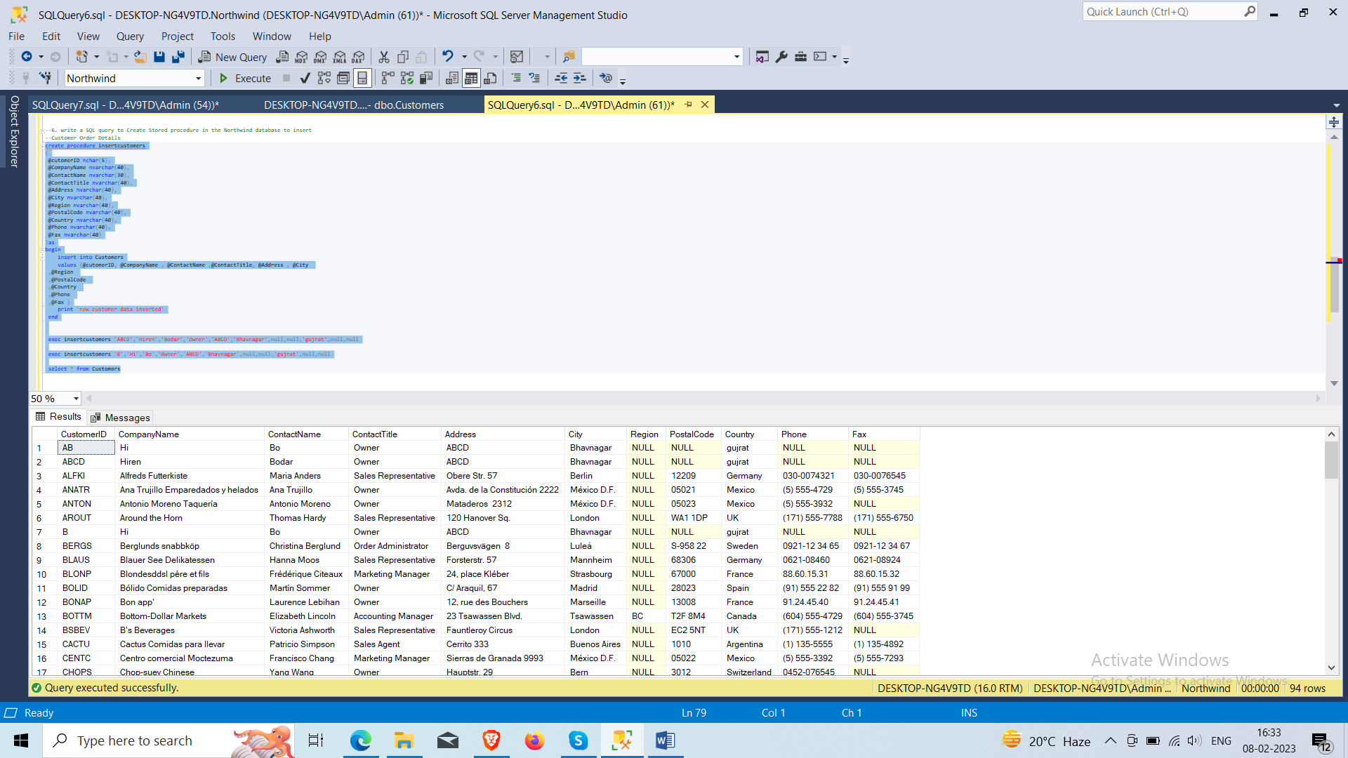

**7. write a SQL query to Create Stored procedure in the Northwind database to update Customer Order Details**

update Orders

set EmployeeID = 6

where OrderID=10248

